Feature Tables
ID | Feature | User story | Actor | Priority
LOAN-01 | Loan application | As a customer, I want to submit a loan application (amount, term, purpose, income) and track its status so that I know whether the bank will lend to me. | Customer | Must
LOAN-02 | Credit scoring and decision | As the bank, I want every application to be scored automatically so that low scores are rejected, high scores approved, and borderline cases reviewed by a loan officer who approves (creating an offer) or rejects. | System, Loan officer | Must
LOAN-03 | Offer, e-signing and payout | As a customer, I want to review the offer, sign it electronically (or decline it) and receive the money on my account right after signing. | Customer, System | Must
LOAN-04 | Installment schedule and collection | As a customer, I want to see my installment schedule (date, principal, interest, total) and have installments debited automatically on the due date. | Customer, System | Should
LOAN-05 | Late payment handling | As the bank, I want missed installments marked late and reminders sent after 3 and 7 days. | System | Should
LOAN-06 | Loan calculator | As a prospective customer, I want to enter amount and term and see the estimated monthly payment before applying. | Customer | Could

ID | Feature | User story | Actor | Priority
ACC-01 | End-of-day ledger posting | As an accountant, I want all the day's money movements (transfers, card transactions, loan payouts, installments) posted as balanced debit/credit entries in one nightly batch. | System | Must
ACC-02 | General ledger view | As an accountant, I want to browse and filter ledger entries by account, date and transaction. | Accountant | Must
ACC-03 | Reconciliation and discrepancy handling | As an accountant, I want total debits compared with total credits daily and any discrepancy sent to me with details so that I can investigate it. | System, Accountant | Must
ACC-04 | Financial reports | As an accountant, I want to generate a balance sheet and income statement for a chosen period and export them. | Accountant | Should
ACC-05 | Chart of accounts management | As an accountant, I want to add or deactivate ledger accounts so that the chart matches the bank's needs. | Accountant | Should
ACC-06 | Customer monthly statement | As a customer, I want a monthly statement of my account activity. | Customer | Could

Business Flows
Loan application
A customer with approved KYC submits a loan application. The system validates it and calculates a credit score. A low score (below 400) is rejected automatically, and a high score (above 700) is approved automatically. A score in between goes to a loan officer, who approves it or rejects it with a reason. Once approved, the customer reviews the offer and either signs or declines it. After signing, the system asks CBS to pay out the money, and the installment schedule is created.
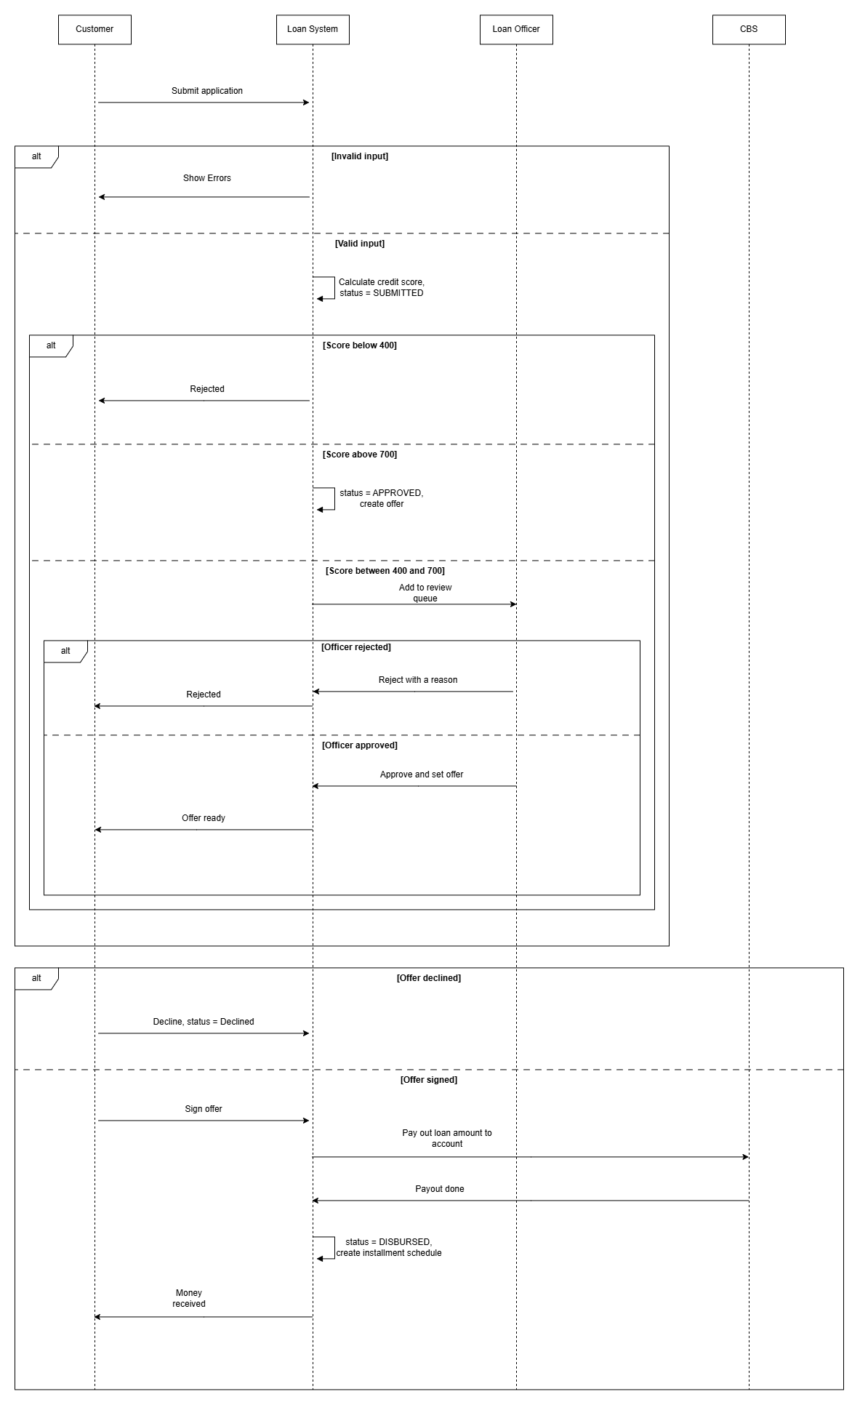
End-of-day posting and reconciliation
Every night the batch job collects the day’s completed transactions from CBS and posts each one to the ledger as a debit entry and a credit entry, using the posting rules. Transactions without a rule are skipped and flagged. The system then compares total debits with total credits. If they match, the run is complete. If not, the Notification system alerts the accountant, who investigates and resolves the discrepancy.
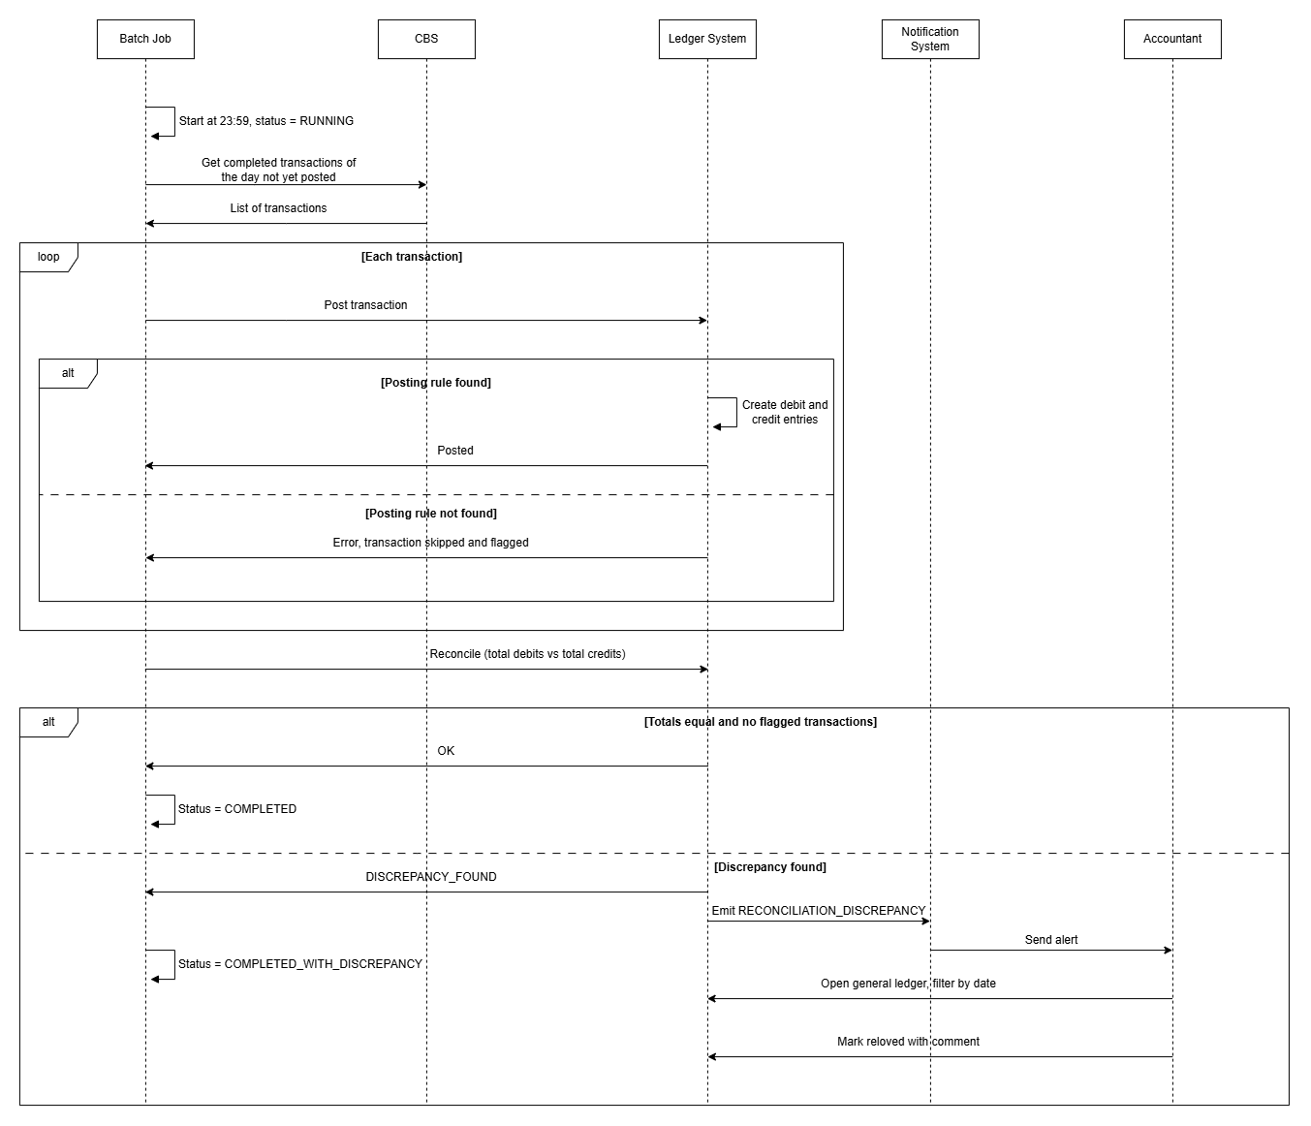

Non-Functional Requirements
NFR-1 | Performance | The EOD batch posts and reconciles all the day’s transactions. | Within 1 hour for up to 100,000 transactions
NFR-2 | Accuracy | Debits equal credits for every posted transaction. Money amounts are stored as Decimal with 2 decimal places, never as floating point. | 0 unbalanced transactions
NFR-3 | Audit | Every loan decision (auto or officer) and every discrepancy resolution is logged with user, time, and old and new status. | 100% of decisions and resolutions logged
NFR-4 | Security | Posted ledger entries cannot be edited or deleted. Corrections are only possible through a new entry. | No update or delete operation exists
NFR-5 | Security | Access depends on role: LOAN_OFFICER sees review screens, ACCOUNTANT sees the ledger and discrepancies, customers see only their own loans. | Role checked on every request

UI/UI Wireframes
Customer
Loans menu -> Loan application -> Submit -> offer ready (when ready) -> Your loan offer -> Sign offer or Decline -> Loans menu

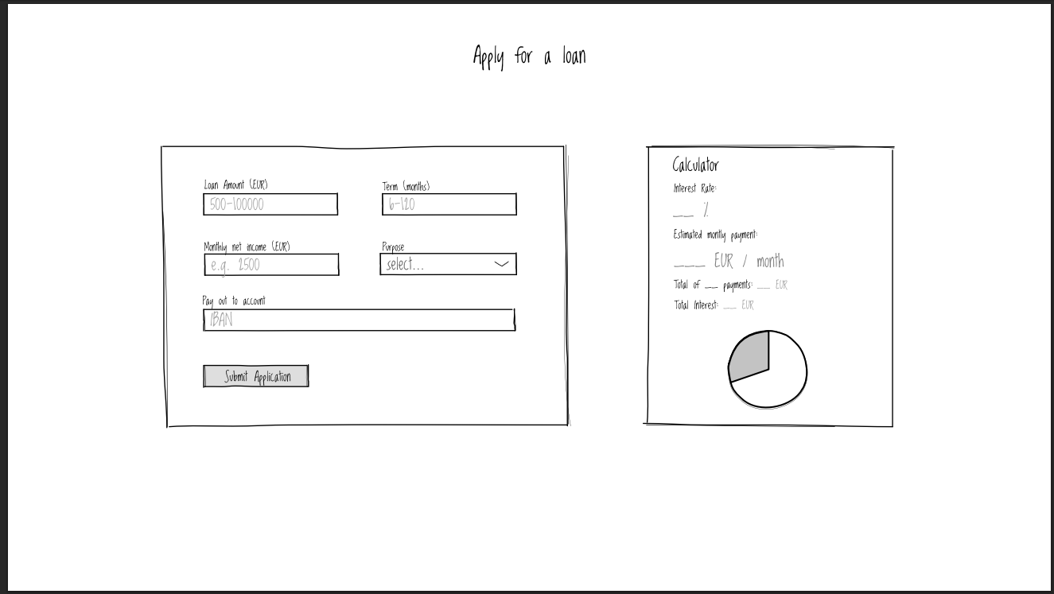

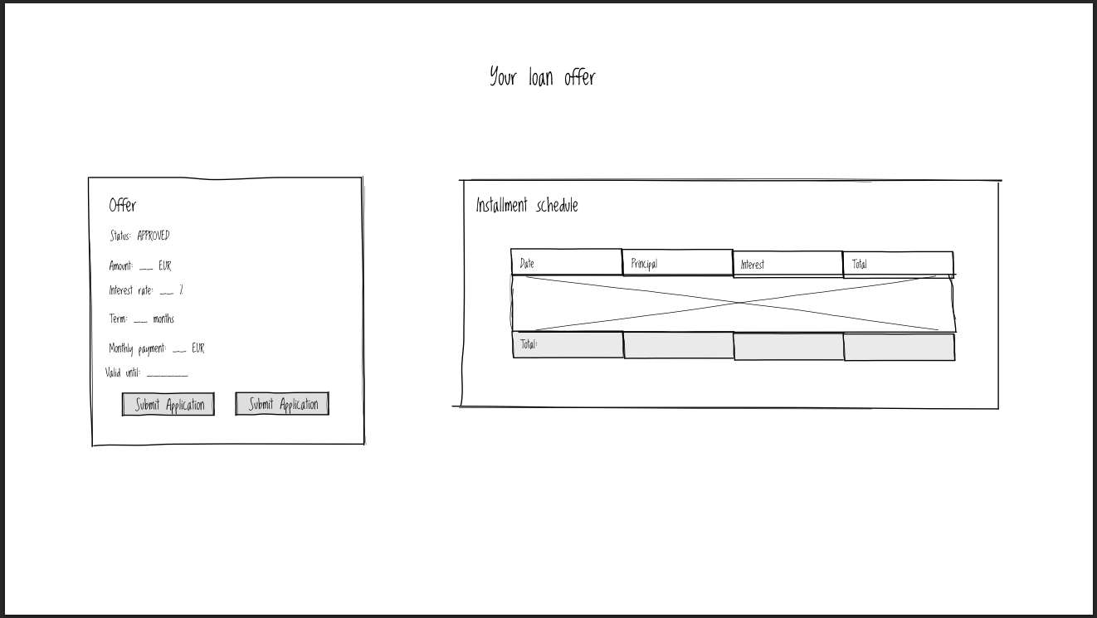
Loan officer
Back-office login -> Loan review -> Approve or Reject -> list refreshes
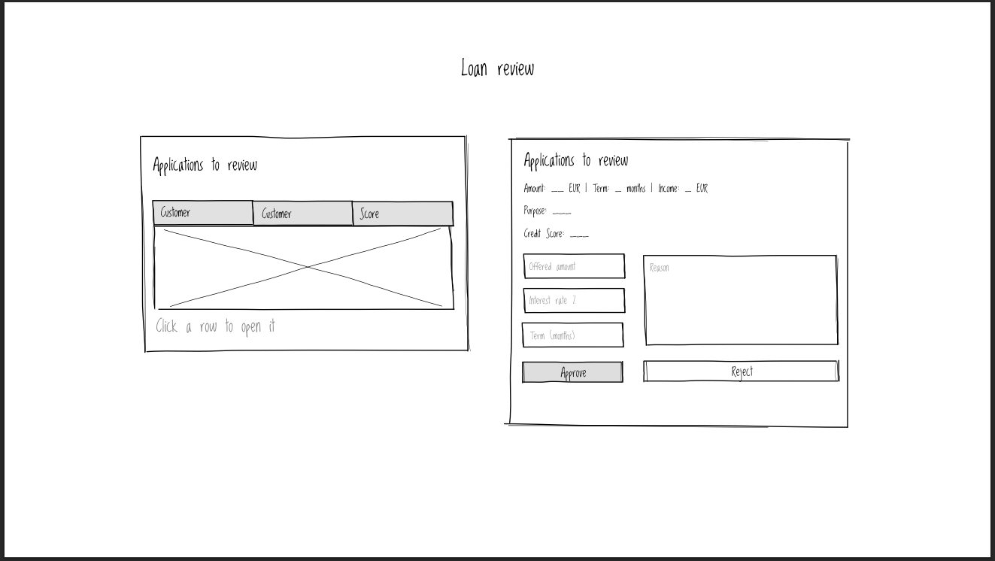
Accountant
Email alert -> General ledger -> Retry posting or Mark resolved -> table refreshes
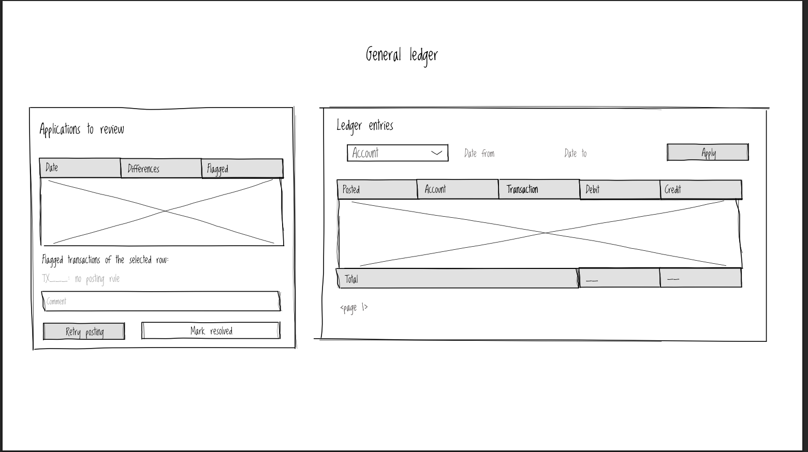
Data model
Loan:
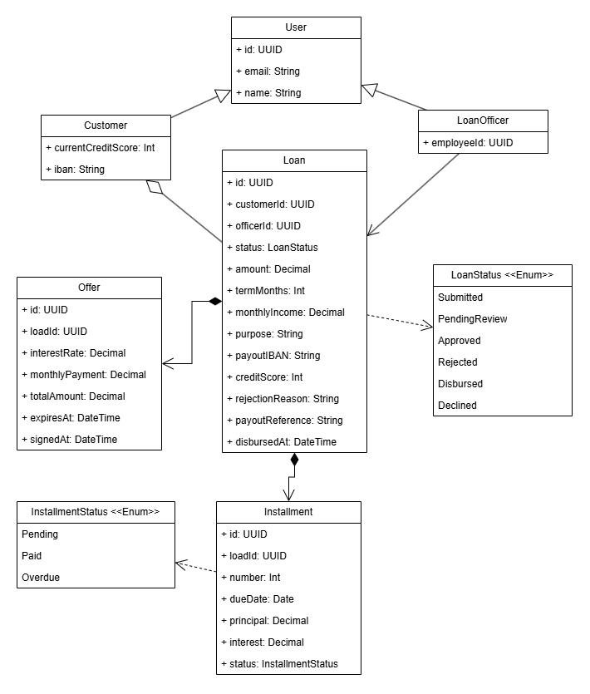
Accounting:
